1. Voting for Two (version 3)
6.RP.A
John and Will ran for 6th grade class president. There were 36 students voting. John got two votes for every vote Will got. It was necessary to get more than half the votes to get elected. How many more votes than half did John get?

2. Gianna's Job
6.RP.3
Gianna is paid $90 for 5 hours of work.
a. At this rate, how much would Gianna make for 8 hours of work?
b. At this rate, how long would Gianna have to work to make $60?

3. 6.RP Hippos Love Pumpkins 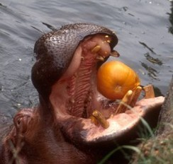
6.RP.2
Hippos sometimes get to eat pumpkins as a special treat.
- If 3 hippos eat 5 pumpkins, how many pumpkins per hippo is that?
- Lindy made 24 jelly-bread sandwiches with a 16-ounce jar of jelly. How many ounces of jelly per sandwich is that?
- Purslane bought 350 rolls of toilet paper for the whole year. How many rolls of toilet paper per month is that?
- In the world's longest running experiment, scientists have tried to capture tar pitch dripping on camera. In the past 86 years, 9 drops have formed. How many years per drop is that?
- Imagine that 12 goats got into a dumpster behind a pizza parlor and ate 3 pizzas. How many goats per pizza would that be? 