Weekly Review # 27 Name:____________
Block:____________

1. Put in order from least to greatest.  $0.25, -1.4, 50\%, 400\%$ | 2. What is the area of the shape below?  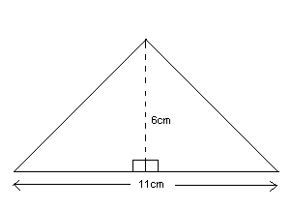
3. Solve for y.  3y≥240 | 4. Solve for y, then draw a number line and graph your answer.  12y<36
5. Which property states that the order of the number can change as long as the operation stays the same?  - Commutative  - Associative  - Distributive  - Identity | 6. What is the volume of a rectangular prism with the following dimensions?  Length: 11 inches  Width: 4.5 inches  Height: 2 inches
7. Estimate.  HINT: Round the smaller number first then find a division fact.  $43.2÷6.8987$ | 8. If a cook uses 15 cups of flour for 3 batches of cookies, how many cups does he use per batch?
9. Combine like terms:  -3+4y-3x+17-y-6x | 10. The Tough Mudder is 10 miles long with obstacles. If it takes Jack 4 minutes to run 0.5 miles and each obstacle takes 3 minutes, how long will it take him to run the Tough Mudder?

